Project Concept Proposal
Brining “Nexus” to Life
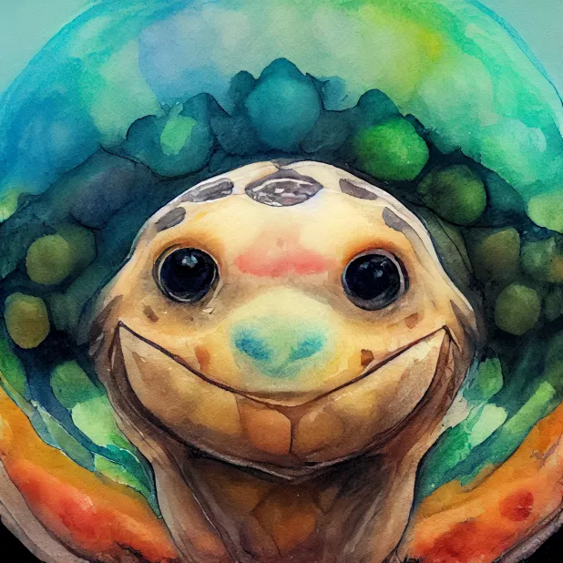
Ken Turman
nexus

Summary.
The project has two main aims—to create a mascot for the GLOBE organization and to conceptualize & create a fountain for the Rosebud Continuum. Through several mediums (2d and 3d), Nexus, the friendly neighborhood Gopher Tortoise will be brought to life. Project will provide 2d Art for future GLOBE designs (handouts, flyers, etc), 3d printable figurines of Nexus, and ultimate building a tortoise fountain using recycled plastic, concrete and painted with multi-hued mold/mildew cultures.

Project Background.
During a recent trip to the Rosebud continuum (RC), I was impressed by the amount and quality of ongoing projects. What was less impressive however, was the visual appeal/Branding of the grounds—it doesn’t “sell” itself well. If the RC is going to act as the showcase for local (and further) possibilities of nexus thinking, targeting and enhancing the aesthetics, while maintaining its core purpose of study and experimentation, is a worthwhile endeavor. Capitalizing on a few ideas and untapped resources (the gopher tortoise habitat, natural benefits of running water, wildlife appeal, area beautification, 3d printer, importance of GLOBE, community outreach), lays the groundwork for an iconic centerpiece as an ideal contribution.

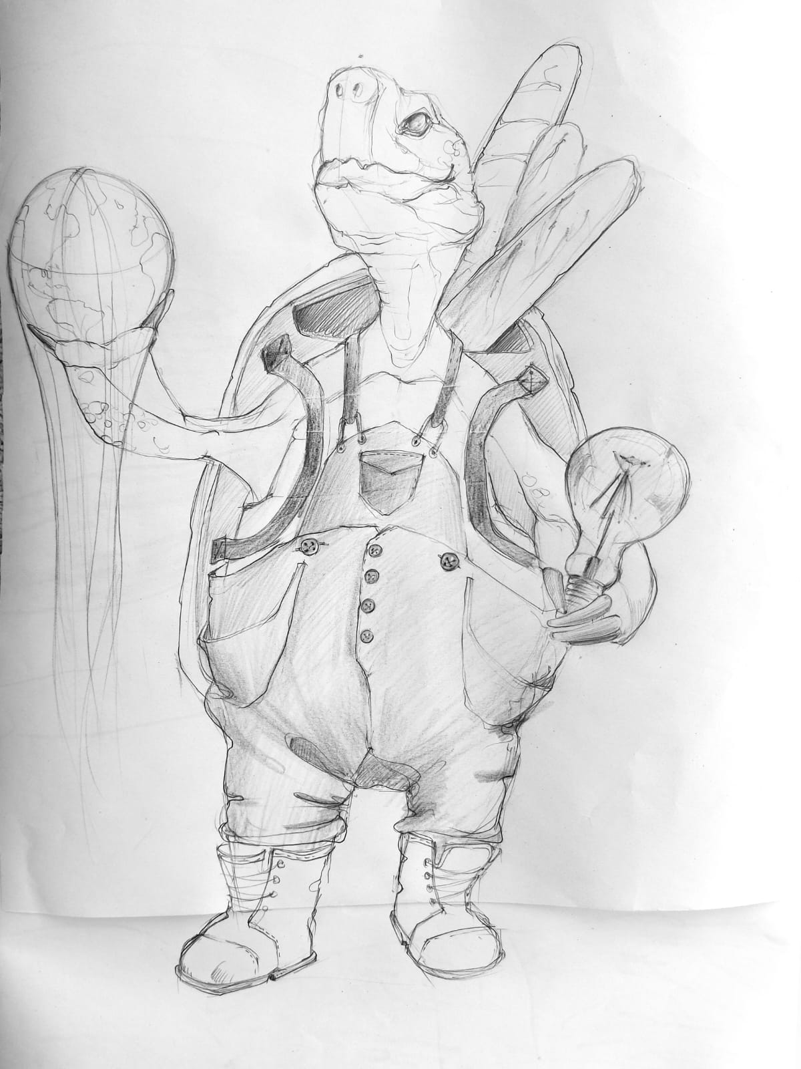
Water
Project Approach.
The project will require a minimum of five contributors and span the course of approximately six months with an unveiling ceremony near the end of March, 2023. Personnel requirements include 2D art lead, 3d Art lead, Mold Painting lead, Event planner, and a sculpting and structure lead. The project will begin slowly during the design phase as multiple artists are providing 2D & 3D renditions of Nexus while mold painting, unveiling event, and the statue’s structure will be conceptualized. Project culminates in an unveiling event, with invites sent to stakeholders as well as current and potential RC doners.
Energy
Food
GLOBE

nexus

Timeline.
The project will progress over several stages, with a few of the items marked by specific role12s:
3C Conception – 3DC
2D Conception – 2DC
Mold Painting – MP
Structure & Sculpting – SS
Event Planner - EP

14SEP - 30MAR 3DC -Complete 3D Printing and Additive Manufacturing Specialization Course
14SEP - 30MAR MP - Experiment with mold ”painting”
14SEP - 28FEB SS – Conceptualize & plan Statue
14SEP – 31MAR EP – Plan Unveiling Ceremony and generate social media “hype”
14SEP - 28 SEP Project Concept Approval
14SEP - 15OCT 2DC- Develop 2D character “Nexus”
15OCT - 30OCT Feedback on design, make adjustments, obtain approval
30OCT - 15NOV Develop 3D model “Nexus”
15NOV - 15DEC Feedback on design, make adjustments, obtain approval
15DEC - 01DEC Print Nexus Figurines for Christmas (100ea).
01DEC – 07DEC MoC - Send invites & figures to unveiling ceremony to current and potential RC supporters
01JAN - 14FEB Translate figurine into functional Fountain
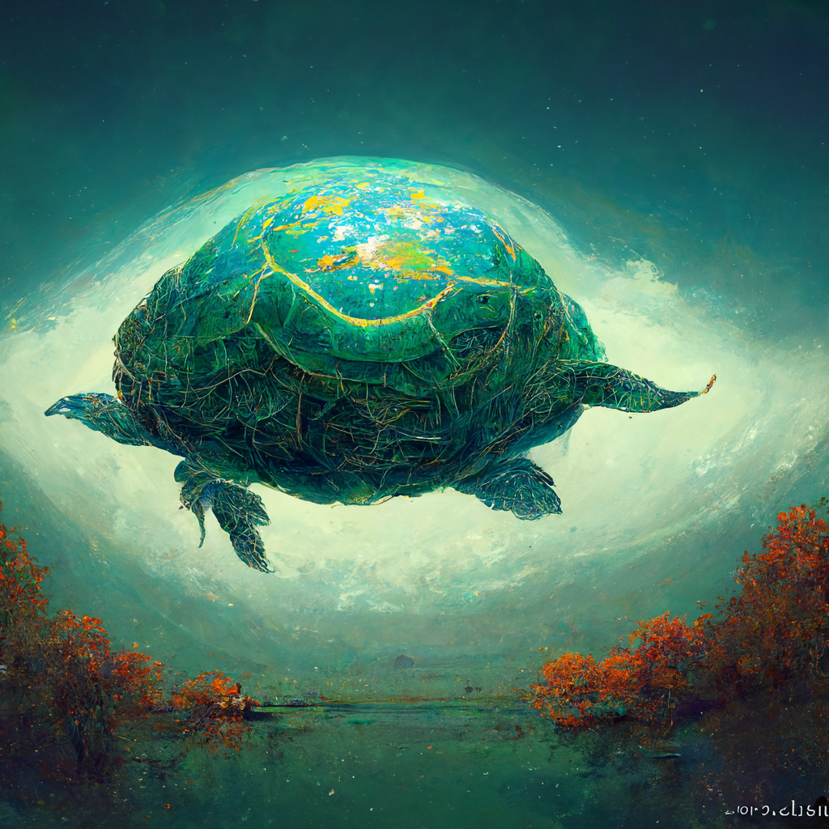
14FEB - 28FEB Feedback on design, make adjustments, obtain approvals
28FEB - 30MAR Create Fountain
31MAR Unveiling ceremony
31MAR Introduce mold & mildew cultures (with live painting event?)

Budget.
The total cost of the project is divided into 4 phases with a total estimated cost of: $4,750
$1000 Conceptualization Phase – Training, art commissioning, mold experimenting
$750 3D Print Phase – materials, invitations,
$2000 Build Phase – weld sculpture structure, sculpt, fountain system, landscaping
$1000 Unveiling Ceremony – Drinks, hors d’oeuvres

Decision Makers.
GLOBE Council (adoption of Nexus mascot)
Dr. Culhane
Rosebud Continuum

Additional information.

